Porker Game

Author | Lori Zhang
Status | Draft
Revision | 1
Last Saved | 9/3/2012 10:30:00 AM

Revision History
Rev | Author | Date | Comments
1 | Lori Zhang

How to join this project
- Sing up/get a new GitHub account in page: https://github.com/
- Find project and set it as Watch: https://github.com/maowenzhang/FWRG
- Send GitHub account name to Lori Zhang
- Install GitHub client: windows - http://windows.github.com/

How to involve in project

How to maintain codes
We use GitHub web site and its client to maintain codes.
https://github.com/maowenzhang/FWRG
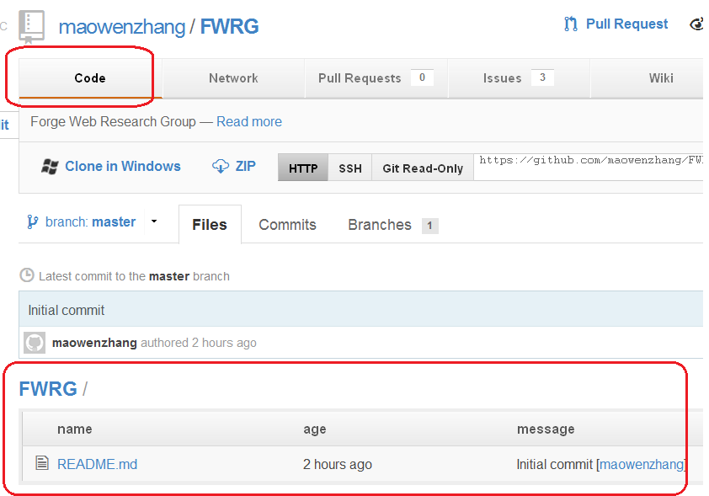
- Web site

How to check status/tasks
We use GitHub web site to track status/tasks/issues of project.

